

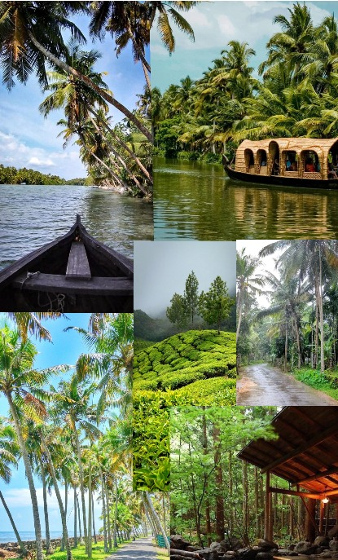
KERALA PACKAGES

INDEX

Sr. No | NIGHT | PACKAGE
01 | 02 NIGHT | MUNNAR 02N
02 | 03 NIGHT | COCHIN 01N+ MUNNAR 02N
03 | 04 NIGHT | COCHIN 01N+ MUNNAR 02N + THEKKDAY 01N
04 | 04 NIGHT | MUNNAR 02N + THEKKADY 01N + ALLEPPEY 01N
05 | 05 NIGHT | COCHIN 01+ MUNNAR 02N + THEKKADY 01N + ALLEPPEY 01N
06 | 05 NIGHT | COCHIN 01 + MUNNAR 02N + THEKKADY 01N + VARKALA 01N
07 | 05 NIGHT | MUNNAR 02N + THEKKDAY 01N + ALLEPPEY 01N + KOVALAM 01N
08 | 06 NIGHT | MUNNAR 02N + THEKKADY 01N +ALLEPPEY 01N + KOVALAM 02N
09 | 07 NIGHT | COCHIN 01 + MUNNAR 02N + THEKKADY 01N + ALLEPPEY 01N + KOVALAM 02N
 |  | HOTEL NAMES , INCLUSION , EXCLUSION

2 NIGHT / 3 DAY
2N Munnar

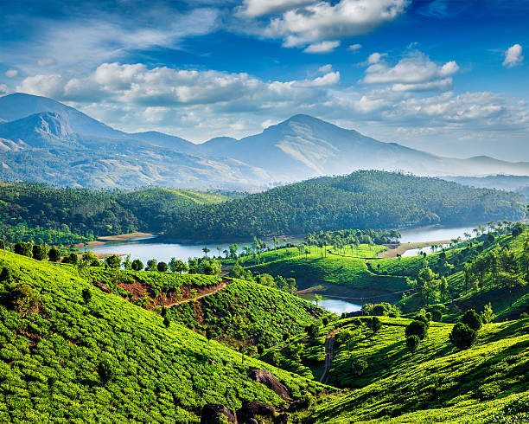

DAY | SHORT ITINERARY | NIGHT STAY
DAY 01 | Cochin to Munnar | MUNNAR
DAY 02 | Full Day Munnar Excursion | MUNNAR
DAY 03 | Munnar to Cochin

Tour Cost Per Person in INR

HOTEL CATEGORY | 2 PAX | 4 PAX | 6 PAX | 8 PAX | 10 PAX | Extra bed | CNB | Meal
3 STAR | 7200 | 5800 | 4900 | 5100 | 4800 | 3100 | 2600 | 1500
3 STAR DELUXE | 7600 | 6300 | 5300 | 5400 | 5100 | 3500 | 2600 | 1500

ITINERARY
Day 1: Cochin to Munnar
After breakfast checkout and to the scenic hill station of Munnar. Also known as the ‘Nature Lover’s Paradise’, your arrival in this hilly abode will be followed by your checking-in into a hotel or a resort. Spent the rest of the day at total leisure while enjoy the stunning beauty of Munnar; overnight stay in the hotel/resort.

Day 2: Full Day Munnar Excursion
A treasure trove for the nature lovers, honeymooners, leisure seekers and all other classes of travelers, Munnar is an ideal sightseeing destination in Kerala! Today morning, after having breakfast, you can embark on a delightful sightseeing tour and discover all the grandeurs of this gorgeous hill station town. On the list, there will be scenic landmarks like Kundala Lake, Elephant Arrival Point, Cinema Shooting Point and several other places. Mattupetty, Tata Tea Museum, Eravikulam National Park, Blossom
Hydel Park, spice plantation will also be visited during the day. By evening, you will be guided back to the hotel/resort for your overnight stay.

Day 03: Munnar to Cochin
After Breakfast check out from the Hotel & Proceed to Cochin Airport/ Railway station for Onward Journey.

3 NIGHT / 4 DAY
1N Cochin - 2N Munnar

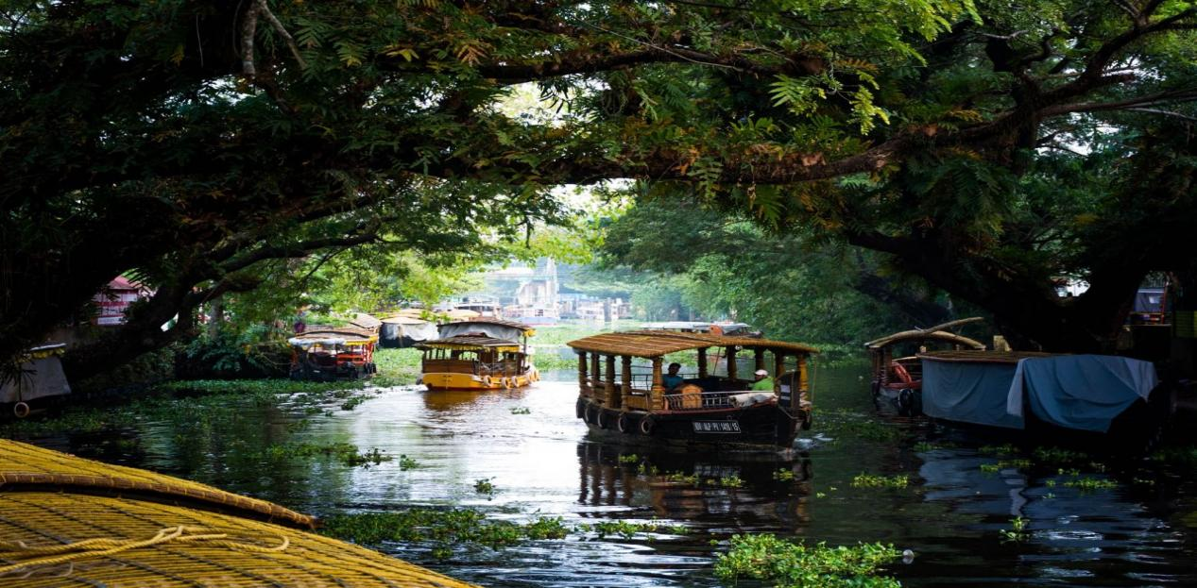

DAY | SHORT ITINERARY | NIGHT STAY
DAY 01 | Cochin | COCHIN
DAY 02 | Munnar | MUNNAR
DAY 03 | Full Day Munnar Excursion | MUNNAR
DAY 04 | Drop Cochin | THEKKADY

Tour Cost Per Person in INR

HOTEL CATEGORY | 2 PAX | 4 PAX | 6 PAX | 8 PAX | 10 PAX | Extra bed | CNB | Meal
3 STAR | 8900 | 7400 | 6300 | 6400 | 6100 | 3900 | 3100 | 2000
3 STAR DELUXE | 9400 | 7900 | 6800 | 6900 | 6400 | 4500 | 3100 | 2000

ITINERARY
Day 1: Cochin

Arrival at Cochin Airport / Railway Station. Transfer to Hotel. Upon arrival check in at hotel after check in the hotel and freshen up proceed to local sightseeing.
Sightseeing: - Fort kochi Chinese fishing net, Mattancherry - Synagouge , Marian drive, Marine walk way, boating (Directly payable). You can find some time for shopping at Cochin, (Sightseeing will be according to time and weather condition.)
Day 2: Cochin to Munnar
After breakfast checkout and driven to the scenic hill station of Munnar. Also known as the ‘Nature Lover’s Paradise’, your arrival in this hilly abode will be followed by your checking-in into a hotel or a resort. Spent the rest of the day at total leisure while enjoy the stunning beauty of Munnar; overnight stay in the hotel/resort.

Day 3: Full Day Munnar Excursion
A treasure trove for the nature lovers, honeymooners, leisure seekers and all other classes of travelers, Munnar is an ideal sightseeing destination in Kerala! Today morning, after having breakfast, you can embark on a delightful sightseeing tour and discover all the grandeurs of this gorgeous hill station town. On the list, there will be scenic landmarks like Kundala Lake, Elephant Arrival Point, Cinema Shooting Point and several other places. Mattupetty, Tata Tea Museum, Eravikulam National Park, Blossom
Hydel Park, spice plantation will also be visited during the day. By evening, you will be guided back to the hotel/resort for your overnight stay.

Day 4: Drop at Cochin

4 NIGHT / 5 DAY
1N COCHIN - 2N Munnar - 1N Thekkady

DAY | SHORT ITINERARY | NIGHT STAY
DAY 01 | Cochin | COCHIN
DAY 02 | Cochin to Munnar | MUNNAR
DAY 03 | Full Day Munnar Excursion | MUNNAR
DAY 04 | Thekkady | THEKKADY
DAY 05 | Drop at Cochin

Tour Cost Per Person in INR

HOTEL CATEGORY | 2 PAX | 4 PAX | 6 PAX | 8 PAX | 10 PAX | Extra bed | CNB | Meal
3 STAR | 10700 | 8900 | 7600 | 7700 | 7200 | 4800 | 3600 | 2900
3 STAR DELUXE | 11300 | 9500 | 8300 | 8400 | 7800 | 5100 | 3600 | 2900

ITINERARY
Day 1: Cochin Sighseeing
Following your arrival at the Cochin International Airport, you will be greeted whole- heartedly by our tour guides and representatives. Post this, you will be driven to the scenic hill station of Munnar. Also known as the ‘Nature Lover’s Paradise’, your arrival in this hilly abode will be followed by your checking-in into a hotel or a resort. Spent the rest of the day at total leisure while enjoy the stunning beauty of Munnar; overnight stay in the hotel/resort.

Day 2: Cochin to Munnar
After breakfast check out move to munnar Post this, you will be driven to the scenic hill station of Munnar. Also known as the ‘Nature Lover’s Paradise’, your arrival in this hilly abode will be followed by your checking-in into a hotel or a resort. Spent the rest of the day at total leisure while enjoy the stunning beauty of Munnar; overnight stay in the hotel/resort.

Day 3: Full Day Munnar Excursion
A treasure trove for the nature lovers, honeymooners, leisure seekers and all other classes of travelers, Munnar is an ideal sightseeing destination in Kerala! Today morning, after having breakfast, you can embark on a delightful sightseeing tour and discover all the grandeurs of this gorgeous hill station town. On the list, there will be scenic landmarks like Kundala Lake, Elephant Arrival Point, Cinema Shooting Point and several other places. Mattupetty, Tata Tea Museum, Eravikulam National Park, Blossom
Hydel Park, spice plantation will also be visited during the day. By evening, you will be guided back to the hotel/resort for your overnight stay.

Day 4: Drive from Munnar to Thekkady

Following your lively Munnar excursion on the previous day, today you will be driven towards Thekkady. Home to the wildlife rich Periyar National Park, this tourist town is known for its candid and untouched beauty. Arriving in Thekkady, check-in into a hotel/resort and after relaxing for a while, you will be taken for a rustic tribal tour to a nearby village followed by a plantation tour. Come evening, you can avail a boat ride (direct payment) in the Periyar Lake and enjoy the wilderness of the Periyar National Park. Returning from the ride, you can indulge in local shopping before retiring into the hotel/resort for your overnight stay.

Day 5: Drop at Cochin

4 NIGHT / 5 DAY
2N Munnar - 1N Thekkady - 1N Alleppey

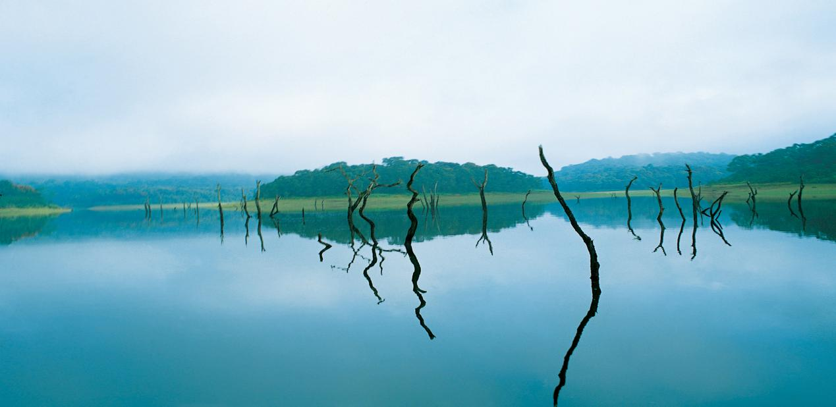

DAY | SHORT ITINERARY | NIGHT STAY
DAY 01 | Cochin - Munnar | MUNNAR
DAY 02 | Full Day Munnar Excursion | MUNNAR
DAY 03 | Munnar- Thekkady | THEKKADY
DAY 04 | Thekkady - Alleppey | ALLEPPEY
DAY 05 | Alleppey to Cochin

Tour Cost Per Person in INR

HOTEL CATEGORY | 2 PAX | 4 PAX | 6 PAX | 8 PAX | 10 PAX | Extra bed | CNB | Meal
3 STAR | 10800 | 9100 | 7800 | 7900 | 7300 | 4800 | 3500 | 2900
3 STAR DELUXE | 11500 | 9700 | 8400 | 8500 | 8100 | 5300 | 3600 | 2900

ITINERARY
Day 1: Arrival in Cochin
Arrival at Cochin , Move to munnar and proceed to the scenic hill station of Munnar. Also known as the ‘Nature Lover’s Paradise’, your arrival in this hilly abode will be followed by your checking-in into a hotel or a resort. Spent the rest of the day at total leisure while enjoy the stunning beauty of Munnar; overnight stay in the hotel/resort.

Day 2: Full Day Munnar Excursion
A treasure trove for the nature lovers, honeymooners, leisure seekers and all other classes of travelers, Munnar is an ideal sightseeing destination in Kerala! Today morning, after having breakfast, you can embark on a delightful sightseeing tour and discover all the grandeurs of this gorgeous hill station town. On the list, there will be scenic landmarks like Kundala Lake, Elephant Arrival Point, Cinema Shooting Point and several other places. Mattupetty, Tata Tea Museum, Eravikulam National Park, Blossom Hydel Park, spice plantation will also be visited during the day. By evening, you will be guided back to the hotel/resort for your overnight stay.

Day 3: Drive from Munnar to Thekkady

Following your lively Munnar excursion on the previous day, today you will be driven towards Thekkady. Home to the wildlife rich Periyar National Park, this tourist town is known for its candid and untouched beauty. Arriving in Thekkady, check-in into a hotel/resort and after relaxing for a while, you will be taken for a rustic tribal tour to a nearby village followed by a plantation tour. Come evening, you can avail a boat ride (direct payment) in the Periyar Lake and enjoy the wilderness of the Periyar National Park. Returning from the ride, you can indulge in local shopping before retiring into the hotel/resort for your overnight stay.

Day 4: Thekkady- Alleppey
After breakfast check out from hotel and transfer to Alleppey is famous for its lovely lakes, lagoons, and freshwater rivers. It’s known as the ‘Venice of the East’ for its similarity to the Italian city. After check in at the hotel and proceed to local sightseeing Coir Factory, Beach, and also enjoy a narrow canal ride with canoe in Alleppey (Directly paid by Guest).

Day 05: Alleppey to Cochin

Morning-After Breakfast check out from the Hotel & Proceed to Cochin Airport/ Railway station for Onward Journey.

5 NIGHT / 6 DAY
1N Cochin - 2N Munnar - 1N Thekkady - 1N Alleppey

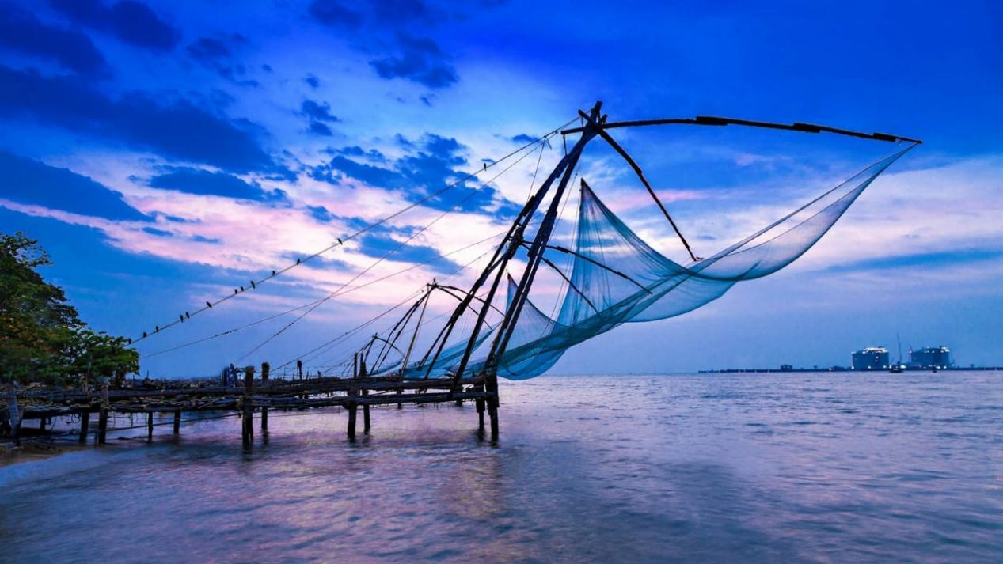

DAY | SHORT ITINERARY | NIGHT STAY
DAY 01 | Cochin | COCHIN
DAY 02 | Munnar | MUNNAR
DAY 03 | Full Day Munnar Excursion | MUNNAR
DAY 04 | Munnar- Thekkady | THEKKADY
DAY 05 | Thekkady - Alleppey | ALLEPPEY
DAY 06 | Cochin Drop

Tour Cost Per Person in INR

HOTEL CATEGORY | 2 PAX | 4 PAX | 6 PAX | 8 PAX | 10 PAX | EB | CNB | Meal
3 STAR | 12400 | 10300 | 8800 | 9100 | 8300 | 5600 | 4100 | 3500
3 STAR DELUXE | 13500 | 11500 | 10100 | 10300 | 9500 | 6100 | 4200 | 3500

ITINERARY
Day 1: Cochin Sightseeing
Following your arrival at the Cochin International Airport, you will be greeted whole- heartedly by our tour guides and representatives. Proceed to Sightseeing, Marine Drive, Fort kochi, Chinese Fishing net. Overnight Kochi

Day 2: Munnar Excursion
After Breakfast, Move to Munnar Post this, you will be driven to the scenic hill station of Munnar. Also known as the ‘Nature Lover’s Paradise’, your arrival in this hilly abode will be followed by your checking-in into a hotel or a resort. Spent the rest of the day at total leisure while enjoy the stunning beauty of Munnar; overnight stay in the hotel/resort.

Day 3: Full Day Munnar Excursion
A treasure trove for the nature lovers, honeymooners, leisure seekers and all other classes of travelers, Munnar is an ideal sightseeing destination in Kerala! Today morning, after having breakfast, you can embark on a delightful sightseeing tour and discover all the grandeurs of this gorgeous hill station town. On the list, there will be scenic landmarks like Kundala Lake, Elephant Arrival Point, Cinema Shooting Point and several other places. Mattupetty, Tata Tea Museum, Eravikulam National Park, Blossom
Hydel Park, spice plantation will also be visited during the day. By evening, you will be guided back to the hotel/resort for your overnight stay.

Day 4: Drive from Munnar to Thekkady

Following your lively Munnar excursion on the previous day, today you will be driven towards Thekkady. Home to the wildlife rich Periyar National Park, this tourist town is known for its candid and untouched beauty. Arriving in Thekkady, check-in into a hotel/resort and after relaxing for a while, you will be taken for a rustic tribal tour to a nearby village followed by a plantation tour. Come evening, you can avail a boat ride (direct payment) in the Periyar Lake and enjoy the wilderness of the Periyar National Park. Returning from the ride, you can indulge in local shopping before retiring into the hotel/resort for your overnight stay.

Day 5: Thekkady- Alleppey
Drive through the Green valley & reach to Silent Back waters –Check into one of the attraction of Kerala Tourism- Houseboat & Greeted with The welcome drink & after that enjoy the Back waters cruise through the Narrow Canals, Paddy Fields with a Cool Breeze. Enjoy the Amazing Back Water Cruise. Night Halt in Houseboat. (AC will be according to timing)

Day 6: Cochin Drop
Today will be the last day of this amazing and enchanting Kerala tour! After breakfast is served, you will be checked-out from the Varkal, and driven to Cochin. Following your drop at the Cochin Airport, this heart- warming tour will come an end.

5 NIGHT / 6 DAY
1N Cochin - 2N Munnar - 1N Thekkady - 1N Varkala

DAY | SHORT ITINERARY | NIGHT STAY
DAY 01 | Cochin | COCHIN
DAY 02 | Munnar Excursion | MUNNAR
DAY 03 | Full Day Munnar Excursion | MUNNAR
DAY 04 | Thekkady | THEKKADY
DAY 05 | Varkala | VARKALA
DAY 06 | Cochin drop

Tour Cost Per Person in INR

HOTEL CATEGORY | 2 PAX | 4 PAX | 6 PAX | 8 PAX | 10 PAX | EB | CNB | Meal
3 STAR | 15500 | 12700 | 10900 | 10800 | 10100 | 6000 | 4200 | 3500
3 STAR DELUXE | 14000 | 11700 | 10100 | 10400 | 9500 | 6100 | 4200 | 3500

ITINERARY
Day 1: Cochin Sightseeing
Following your arrival at the Cochin International Airport, you will be greeted whole- heartedly by our tour guides and representatives. Proceed to Sightseeing, Marine Drive, Fort kochi, Chinese Fishing net. Overnight Kochi

Day 2: Munnar Excursion
After Breakfast, Move to Munnar Post this, you will be driven to the scenic hill station of Munnar. Also known as the ‘Nature Lover’s Paradise’, your arrival in this hilly abode will be followed by your checking-in into a hotel or a resort. Spent the rest of the day at total leisure while enjoy the stunning beauty of Munnar; overnight stay in the hotel/resort.

Day 3: Full Day Munnar Excursion
A treasure trove for the nature lovers, honeymooners, leisure seekers and all other classes of travelers, Munnar is an ideal sightseeing destination in Kerala! Today morning, after having breakfast, you can embark on a delightful sightseeing tour and discover all the grandeurs of this gorgeous hill station town. On the list, there will be scenic landmarks like Kundala Lake, Elephant Arrival Point, Cinema Shooting Point and several other places. Mattupetty, Tata Tea Museum, Eravikulam National Park, Blossom
Hydel Park, spice plantation will also be visited during the day. By evening, you will be guided back to the hotel/resort for your overnight stay.

Day 4: Drive from Munnar to Thekkady

Following your lively Munnar excursion on the previous day, today you will be driven towards Thekkady. Home to the wildlife rich Periyar National Park, this tourist town is known for its candid and untouched beauty. Arriving in Thekkady, check-in into a hotel/resort and after relaxing for a while, you will be taken for a rustic tribal tour to a nearby village followed by a plantation tour. Come evening, you can avail a boat ride (direct payment) in the Periyar Lake and enjoy the wilderness of the Periyar National Park. Returning from the ride, you can indulge in local shopping before retiring into the hotel/resort for your overnight stay.

Day 5: Thekkady- Varkala
After breakfast proceed to Varkala . Checkin at hotel , Later proceed to sightseeing varkala Cliff and beach, Other adventures activities are directly payable by guest. Overnight stay at Hotel.

Day 6: Cochin Drop
Today will be the last day of this amazing and enchanting Kerala tour! After breakfast is served, you will be checked-out from the Varkala, and driven to Cochin. Following your drop at the Cochin Airport, this heart- warming tour will come an end.

5 NIGHT / 6 DAY
2N Munnar - 1N Thekkady - 1N Alleppey - 1N Kovalam

DAY | SHORT ITINERARY | NIGHT STAY
DAY 01 | Cochin to Munnar | MUNNAR
DAY 02 | Full Day Munnar Excursion | MUNNAR
DAY 03 | Munnar- Thekkady | THEKKADY
DAY 04 | Thekkady - Alleppey | ALLEPPEY
DAY 05 | Alleppey - Kovalam | KOVALAM
DAY 06 | Kovalam to Trivandrum drop

Tour Cost Per Person in INR

HOTEL CATEGORY | 2 PAX | 4 PAX | 6 PAX | 8 PAX | 10 PAX | EB | CNB | Meal
3 STAR | 14000 | 11700 | 10100 | 10400 | 9500 | 5800 | 4100 | 3600
3 STAR DELUXE | 16000 | 13200 | 11200 | 11400 | 10500 | 6200 | 4100 | 3600

ITINERARY
Day 1: Cochin to Munnar
Following your arrival at the Cochin International Airport, you will be greeted whole- heartedly by our tour guides and representatives. Post this, you will be driven to the scenic hill station of Munnar. Also known as the ‘Nature Lover’s Paradise’, your arrival in this hilly abode will be followed by your checking-in into a hotel or a resort. Spent the rest of the day at total leisure while enjoy the stunning beauty of Munnar; overnight stay in the hotel/resort.

Day 2: Full Day Munnar Excursion
A treasure trove for the nature lovers, honeymooners, leisure seekers and all other classes of travelers, Munnar is an ideal sightseeing destination in Kerala! Today morning, after having breakfast, you can embark on a delightful sightseeing tour and discover all the grandeurs of this gorgeous hill station town. On the list, there will be scenic landmarks like Kundala Lake, Elephant Arrival Point, Cinema Shooting Point and several other places. Mattupetty, Tata Tea Museum, Eravikulam National Park, Blossom
Hydel Park, spice plantation will also be visited during the day. By evening, you will be guided back to the hotel/resort for your overnight stay.

Day 3: Drive from Munnar to Thekkady

Following your lively Munnar excursion on the previous day, today you will be driven towards Thekkady. Home to the wildlife rich Periyar National Park, this tourist town is known for its candid and untouched beauty. Arriving in Thekkady, check-in into a hotel/resort and after relaxing for a while, you will be taken for a rustic tribal tour to a nearby village followed by a plantation tour. Come evening, you can avail a boat ride (direct payment) in the Periyar Lake and enjoy the wilderness of the Periyar National Park. Returning from the ride, you can indulge in local shopping before retiring into the hotel/resort for your overnight stay.

Day 4: Thekkady- Alleppey
After breakfast check out from hotel and transfer to Alleppey is famous for its lovely lakes, lagoons, and freshwater rivers. It’s known as the ‘Venice of the East’ for its similarity to the Italian city. After check in at the hotel and proceed to local sightseeing Coir Factory, Beach, and also enjoy a narrow canal ride with canoe in Alleppey (Directly paid by Guest).

Day 5: Alleppey - Kovalam
From the ‘Backwater Capital’, today you will be driven to Kovalam, the ‘Beach Capital’ of Kerala. The journey will start post breakfast and will take around 4 hours. Arriving in Kovalam, you will be taken to the Kovalam Beach, where you can enjoy several beach activities. Adorned by the playful waves of the Arabian Sea, this sandy retreat is visited by a large number of beach lovers and is ideal for activities like swimming, sunbathing, herbal body massages, water sports and lot more. With the advent of the evening, you will be checked-in into a beach resort for your overnight stay.

Day 6: Trivandrum Drop
Today will be the last day of this amazing and enchanting Kerala tour! After breakfast is served, you will be checked-out from the Kovalam, and driven to Trivandrum. Following your drop at the Trivandrum Airport, this heart- warming tour will come an end.

6 NIGHT / 7 DAY
2N Munnar - 1N Thekkady - 1N Alleppey - 2N Kovalam

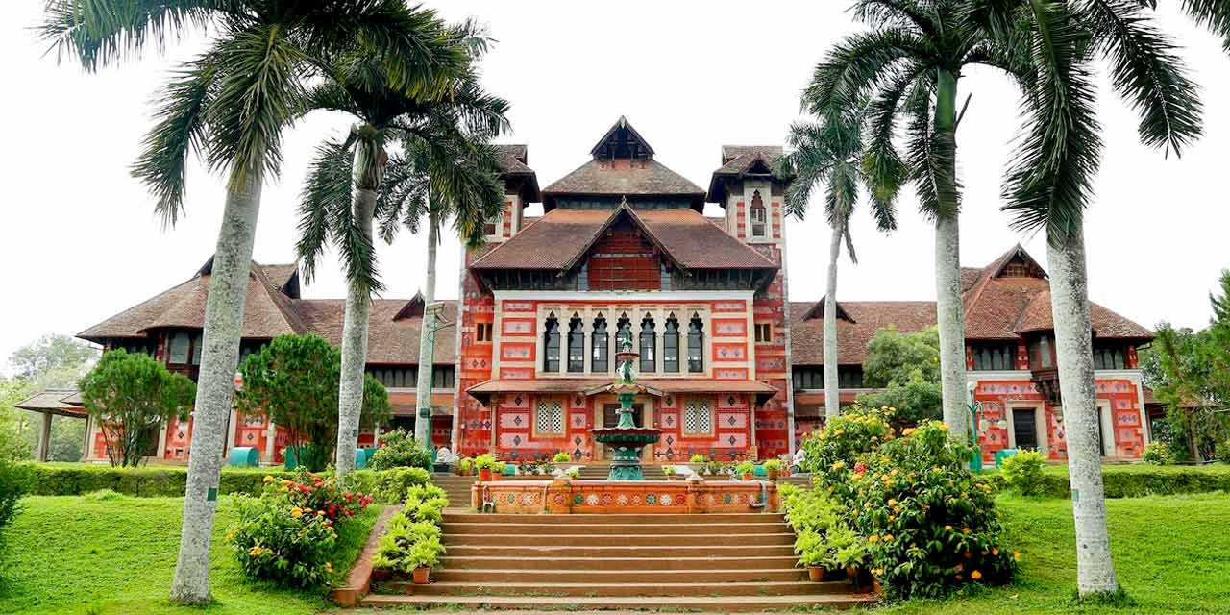

DAY | SHORT ITINERARY | NIGHT STAY
DAY 01 | Cochin to Munnar | MUNNAR
DAY 02 | Full Day Munnar Excursion | MUNNAR
DAY 03 | Munnar- Thekkady | THEKKADY
DAY 04 | Thekkady - Alleppey | ALLEPPEY
DAY 05 | Alleppey - Kovalam | KOVALAM
DAY 06 | Kovalam | KOVALAM
DAY 07 | Kovalam to Trivandrum drop

Tour Cost Per Person in INR

HOTEL CATEGORY | 2 PAX | 4 PAX | 6 PAX | 8 PAX | 10 PAX | Extra bed | CNB | Meal
3 STAR | 16400 | 13300 | 11300 | 11500 | 10700 | 6600 | 4500 | 4200
3 STAR DELUXE | 17600 | 14700 | 12700 | 12800 | 12000 | 7100 | 4600 | 4200

ITINERARY
Day 1: Cochin to Munnar
Following your arrival at the Cochin International Airport, you will be greeted whole- heartedly by our tour guides and representatives. Post this, you will be driven to the scenic hill station of Munnar. Also known as the ‘Nature Lover’s Paradise’, your arrival in this hilly abode will be followed by your checking-in into a hotel or a resort. Spent the rest of the day at total leisure while enjoy the stunning beauty of Munnar; overnight stay in the hotel/resort.

Day 2: Full Day Munnar Excursion
A treasure trove for the nature lovers, honeymooners, leisure seekers and all other classes of travellers, Munnar is an ideal sightseeing destination in Kerala! Today morning, after having breakfast, you can embark on a delightful sightseeing tour and discover all the grandeurs of this gorgeous hill station town. On the list, there will be scenic landmarks like Kundala Lake, Elephant Arrival Point, Cinema Shooting Point and several other places. Mattupetty, Tata Tea Museum, Eravikulam National Park, Blossom
Hydel Park, spice plantation will also be visited during the day. By evening, you will be guided back to the hotel/resort for your overnight stay.

Day 3: Drive from Munnar to Thekkady

Following your lively Munnar excursion on the previous day, today you will be driven towards Thekkady. Home to the wildlife rich Periyar National Park, this tourist town is known for its candid and untouched beauty. Arriving in Thekkady, check-in into a hotel/resort and after relaxing for a while, you will be taken for a rustic tribal tour to a nearby village followed by a plantation tour. Come evening, you can avail a boat ride (direct payment) in the Periyar Lake and enjoy the wilderness of the Periyar National Park. Returning from the ride, you can indulge in local shopping before retiring into the hotel/resort for your overnight stay.

Day 4: Thekkady- Alleppey
Drive through the Green valley & reach to Silent Back waters –Check into one of the attraction of Kerala Tourism- Houseboat & Greeted with The welcome drink & after that enjoy the Back waters cruise through the Narrow Canals, Paddy Fields with a Cool Breeze. Enjoy the Amazing Back Water Cruise. Night Halt in Houseboat. (AC will be according to timing)

Day 5: Alleppey - Kovalam
After breakfast check out from hotel and transfer to Alleppey is famous for its lovely lakes, lagoons, and freshwater rivers. It’s known as the ‘Venice of the East’ for its similarity to the Italian city. After check in at the hotel and proceed to local sightseeing Coir Factory, Beach, and also enjoy a narrow canal ride with canoe in Alleppey (Directly paid by Guest).
.

Day 6: Kovalam

After breakfast proceed for Trivandrum City for a short sightseeing around the city. This includes visit to the Napier Museum, Sri Chithira Art Gallery, Sri Padmanabha Swami Temple premises and Kuthiramalika Museum, Kanakakunnu Palace.

Day 7: Trivandrum drop
Today will be the last day of this amazing and enchanting Kerala tour! After breakfast is served, you will be checked-out from the Kovalam beach resort, and driven to Trivandrum. Following your drop at the Trivandrum Airport, this heart- warming tour will come an end.

7 NIGHT / 8 DAY
1N Cochin - 2N Munnar - 1N Thekkady - 1N Alleppey - 2N Kovalam

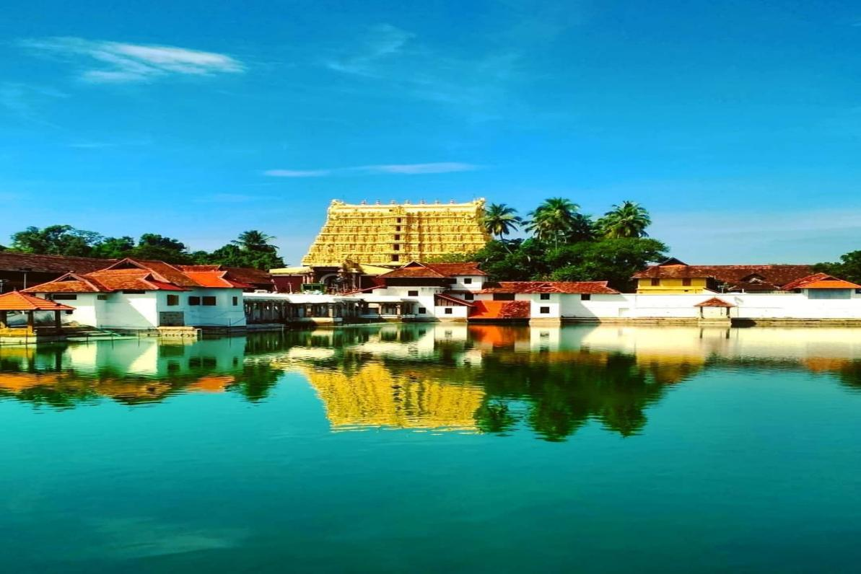

DAY | SHORT ITINERARY | NIGHT STAY
DAY 01 | Cochin | COCHIN
DAY 02 | Cochin to Munnar | MUNNAR
DAY 03 | Full Day Munnar Excursion | MUNNAR
DAY 04 | Munnar- Thekkady | THEKKADY
DAY 05 | Thekkady - Alleppey | ALLEPPEY
DAY 06 | Alleppey - Kovalam | KOVALAM
DAY 07 | Kovalam | KOVALAM
DAY 08 | Kovalam to Trivandrum drop

Tour Cost Per Person in INR

HOTEL CATEGORY | 2 PAX | 4 PAX | 6 PAX | 8 PAX | 10 PAX | Extra bed | CNB | Meal
3 STAR | 17700 | 14900 | 12800 | 13000 | 12200 | 7400 | 5200 | 4800
3 STAR DELUXE | 18900 | 16000 | 14000 | 14200 | 13300 | 7900 | 5200 | 4800

ITINERARY
Day 1: Arrival in Cochin

Cochin, the confluence point of the alluring Arabian Sea and the Silent Backwater, will be your host for the day. With your arrival in this pictorial port-city, you will be warmly greeted by our representatives. Hereafter, you will be checked-in into a hotel, where you can unwind, relax and get freshened up. Sightseeing: - Marian drive, Fort Kochi, Mattancherry. You can find some time for shopping at Cochin, and Chinese fishing Net etc. Overnight stay at hotel.

Day 2: Cochin to Munnar
After breakfast checkout and proceed to the scenic hill station of Munnar. Also known as the ‘Nature Lover’s Paradise’, your arrival in this hilly abode will be followed by your checking-in into a hotel or a resort. Spent the rest of the day at total leisure while enjoy the stunning beauty of Munnar; overnight stay in the hotel/resort.

Day 3: Full Day Munnar Excursion
A treasure trove for the nature lovers, honeymooners, leisure seekers and all other classes of travelers, Munnar is an ideal sightseeing destination in Kerala! Today morning, after having breakfast, you can embark on a delightful sightseeing tour and discover all the grandeurs of this gorgeous hill station town. On the list, there will be scenic landmarks like Kundala Lake, Elephant Arrival Point, Cinema Shooting Point and several other places. Mattupetty, Tata Tea Museum, Eravikulam National Park, Blossom Hydel Park, spice plantation will also be visited during the day. By evening, you will be guided back to the hotel/resort for your overnight stay.

Day 4: Drive from Munnar to Thekkady

Following your lively Munnar excursion on the previous day, today you will be driven towards Thekkady. Home to the wildlife rich Periyar National Park, this tourist town is known for its candid and untouched beauty. Arriving in Thekkady, check-in into a hotel/resort and after relaxing for a while, you will be taken for a rustic tribal tour to a nearby village followed by a plantation tour. Come evening, you can avail a boat ride (direct payment) in the Periyar Lake and enjoy the wilderness of the Periyar National Park. Returning from the ride, you can indulge in local shopping before retiring into the hotel/resort for your overnight stay.

Day 5: Thekkady- Alleppey
Drive through the Green valley & reach to Silent Back waters –Check into one of the attraction of Kerala Tourism- Houseboat & Greeted with The welcome drink & after that enjoy the Back waters cruise through the Narrow Canals, Paddy Fields with a Cool Breeze. Enjoy the Amazing Back Water Cruise. Night Halt in Houseboat. (AC will be according to timing)

Day 6: Alleppey - Kovalam
From the ‘Backwater Capital’, today you will be driven to Kovalam, the ‘Beach Capital’ of Kerala. The journey will start post breakfast and will take around 4 hours. Arriving in Kovalam, you will be taken to the Kovalam Beach, where you can enjoy several beach activities. Adorned by the playful waves of the Arabian Sea, this sandy retreat is visited by a large number of beach lovers and is ideal for activities like swimming, sunbathing, herbal body massages, water sports and lot more. With the advent of the evening, you will be checked-in into a beach resort for your overnight stay.

Day 7: Kovalam

After breakfast proceed for Trivandrum City for a short sightseeing around the city. This includes visit to the Napier Museum, Sri Chithira Art Gallery, Sri Padmanabha Swami Temple premises and Kuthiramalika Museum, Kanakakunnu Palace.

Day 8: Trivandrum drop
Today will be the last day of this amazing and enchanting Kerala tour! After breakfast is served, you will be checked-out from the Kovalam beach resort, and driven to Trivandrum. Following your drop at the Trivandrum Airport, this heart- warming tour will come an end.

HOTELS / INCLUSION / EXCLUSION

HOTEL CATEGORY | COCHIN | MUNNAR | THEKKADY | ALLEPPEY | VARKALA | KOVALAM
3 STAR | North centre / Similar | North centre / Similar | Patio / similar | Venice eva / similar | West bay marisol / similar | Jasmine palace / similar
3 STAR DELUXE | North centre / Similar | Arbour / Similar | Cardamom / similar | Venice eva / similar | West bay marisol / similar | Country club / similar

Package Cost Includes
- Meal as per the meal plan will be served in all the Hotels.
- Accommodation on with above mention category rooms in all the hotels.
- A/C Cab for all transfers and sightseeing exactly as per the itinerary.
- Toll, Parking, driver’s Bata, road tax & fuel charges.
- Pick up from Airport/ Railway Station.
- Drop at Airport/ Railway Station.
- 02 PAX - SEDAN
- 04 PAX - ERTIGA
- 06 PAX - INNOVA
- 08-12 PAX - 12 SEAT TEMPO TRAVELLER

THE ABOVE QUOTE IS SUBJECT TO CHANGE AS PER THE AVAILABILITY OF ROOMS (NO ROOMS ARE RESERVED)

Package Cost Excludes
- Meals not mentioned above.
- GST
- Entry Fees to Monuments and Palaces.
- Anything Not Mentioned in The Inclusions.
- Tickets, tips, guided and Entrance Fees/ Charges.
- Porterage At Hotels and Airports, Tips, Insurance, Laundry, Liquors, Wine, Etc
- Any Increase in Taxes or Fuel Leading to an Increase in Surface Transport.
- Ayurveda Charges.
- Any Cost Arising Due to Natural Calamities Like Landslides, Roadblocks, Etc.
- All items of personal nature.
Kindly Note

- Package Valid till Sept 2026
- Religious place only Vegetarian food will be severed in the hotel.
- Only Non Ac Rooms Are Provided in Munnar, Thekkady etc As They Are Hill.
- Below 6 Years kids are complimentary.
- Vehicle kilometer is calculated on garage to garage basis.
- Itinerary if given is purely suggestive and optional and service will be provided only as per the quote.
- Cab at disposal only from 08:00 hrs. to 18:00 hrs.

Kindly note that rooms / rates are subject to availability at the time of confirmation.

Warm regards,
Bhavana. B. Karotte

Xpedia Holidays
First floor, Apsara arcade,
MKK Nair Road, Palarivattom
Kochi, Kerala 682025
www.xpediaholidays.com
+91 85909 47107 / +91 73068 08988

